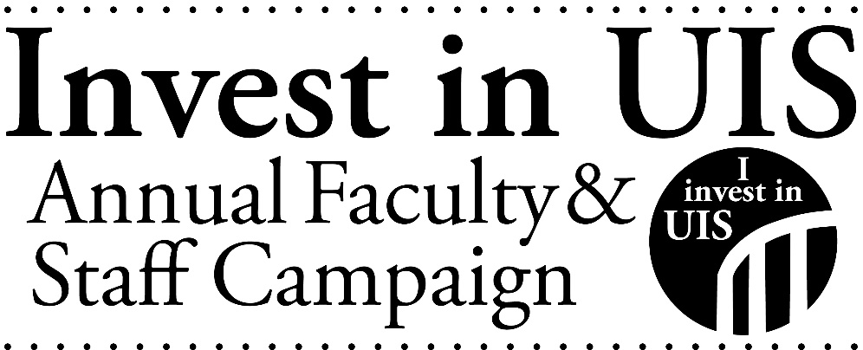
Where UIS Employees Gave in Fiscal Year 2022 (all funds)

Academic Affairs Fund for Excellence
Alternative Spring Break
Alumni Association Scholarship
Astronomy
Athletics Unrestricted
Bill and Frances Cosgrove Water Resource Management Scholarship
Black Student Union
Campus Recreation
CAP Honors Study Away Scholarship
Career Development Center
Center for Online Learning, Research and Service
Chancellor's Fund for Excellence
Chancellor's Unrestricted Fund
Cheerleading
Child Care Center
Child Residential RSL
Christian Student Fellowship
College of Business and Management
College of Business and Management Scholarship
College of Education and Human Services
College of Public Affairs & Administration
College of Public Affairs & Administration Scholarship
College Republicans
Communication
David Everson Memorial Fund
Diversity Center
Dr. Clarice Ford "Whatever It Takes" Fund
Dr. Rassule Hadidi MIS Scholarship
Educational Leadership
Feng-Shun "Leo" Bin Memorial Finance Student Support Fund
Field Station at Lake Springfield
Field Stations General Fund
Friends of Brookens Library
Friends of Emiquon Project
FRIENDS of UIS Performing Arts Center

Gender and Sexuality Student Services
Gobberdiel Endowment
Gonulsen Athletic Scholarship
Good as Gold Ceremony
Gus Pflugmacher Basketball Scholarship
History
Hockenyos Family Scholarship
Human Development Counseling
Illinois Innocence Project
Information Technology Services
Innovate Springfield
Intercollegiate Baseball
Julie and William Kellner Working Student Scholarship
K Fund
Karen Swan Memorial
Landscape and Garden Fund
Leonard Branson Accountancy Scholarship
Library Fund
Lincoln Legacy Lecture Series
Lincoln Studies
Madeline Roy Memorial Scholarship
Medical Laboratory Science Student Support Fund
Men’s Cross Country and Track
Men's Basketball
Men's Golf
Men's Soccer
Men's Soccer Scholarships
Men's Tennis
Military/Veterans Emergency Grant
Model United Nations
Music
Music Lessons Award
Music Merit Awards
Necessary Steps Mentoring Program
NPR Illinois
NPR Illinois Quasi-Endowment
Office of Disability Services
Our Stage Our Voices Program
Plaque and Memorial Fund
Public Affairs Reporting

Rand Linton Megginson Memorial Scholarship
Rosie Richmond Scholarship
Safe Zone
Sangamon Experience
Schweighauser Astronomy Fund
Shelterbelt Reading Series
Speech and Debate Team
Staff Scholarship
Stars Athletics Scholarship Society
Stars Supply Shop
Student Affairs Fund for Excellence
Student Chapter of the Society for Advancement of Management
Student Managed Investment Fund
Student Union Building
Students Transitioning for Academic Retention and Success (STARS)
Suzanna Kay Shiner Scholarship
Ted Mims Scholarship
Terri Jackson Book Award
Theatre
Theatre Scholarship
UIS Alumni Association
UIS Cares Food Panrty
UIS Fund
UIS Journal Newspaper
UIS Scholarship Fund
Undergraduate Student Research
Violet Rose Salela Music Scholarship
Visual Arts Gallery
Volunteer and Civic Engagement Center
Women’s Cross Country and Track
Women's Basketball
Women's Center
Womens Golf
Women's Soccer
Womens Softbal
Womens Tennis
Women's Volleyball
Women's Volleyball Scholarships

